

**Video Server and Client**

**Submitted to:**

Prof. Cherine Saleh

Eng. Marwan Nour

**Submitted by:**

Shady Tarek 19100178

Ahmed Khairy 19100561

Kareem Akram 19102827

Yousef Shalaby 19103854

Raneem Abdelwahab 19101342

Aya Barakat 19102308

**Project description**

The project talks about a video library stored in a server that can be accessed by clients where he sends a request on TCP module then receives the video and get watched on the client device.

A video streaming server is an application that allows users to access and stream video content from a central location. This can be achieved by having one computer act as a server that stores a library of videos. Other computers can then connect to this server and stream the videos in real-time.

The server can be set up using various programming languages and technologies. For example, it can be created using Python and socket programming or by leveraging existing libraries such as (python-ffmpeg-video-streaming) and (pylivestream). These libraries provide tools and functionalities to help package media content for online streaming and stream to one or multiple sites simultaneously.

Once the server is set up, users can connect to it using a client application. This client application can be developed for various platforms such as web browsers, mobile devices, and smart TVs. The client application communicates with the server to request and receive video streams.

The video streaming server can also implement features such as user authentication, video search, and video recommendations. This allows for a personalized and user-friendly experience like popular video streaming platforms like YouTube.

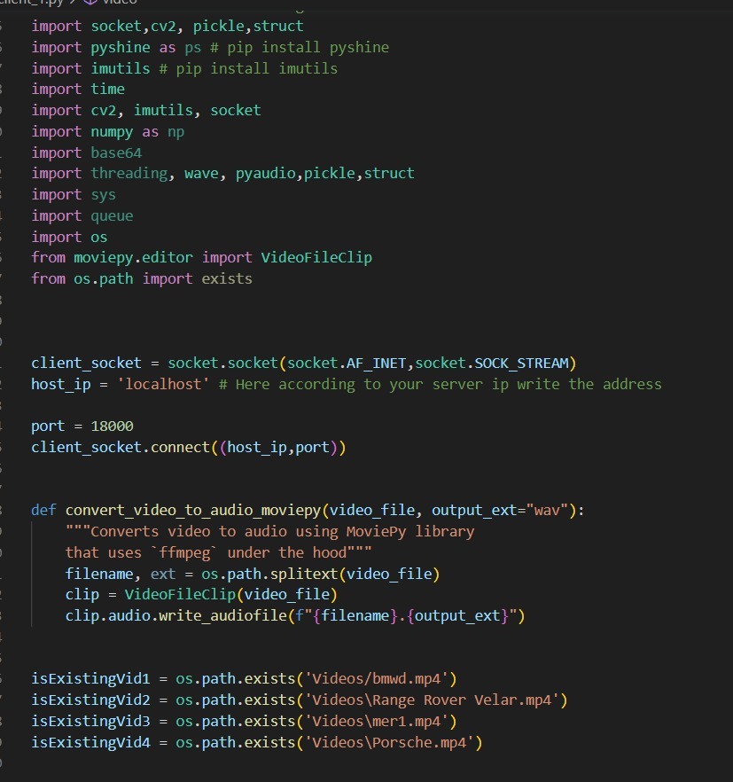**Snips from server code (local host):**



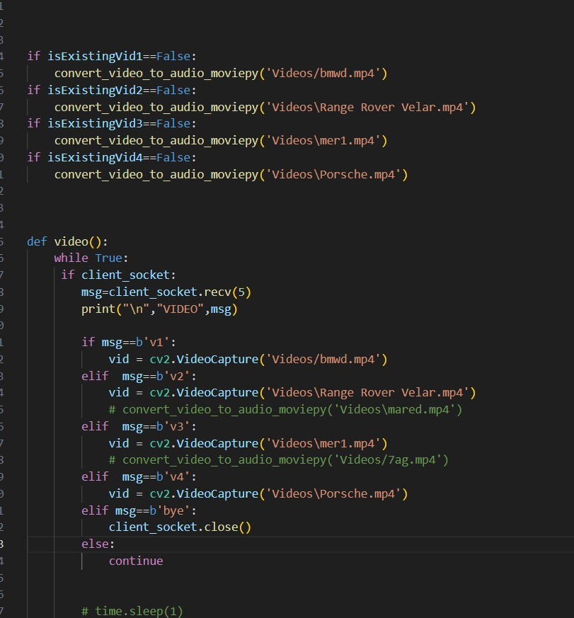

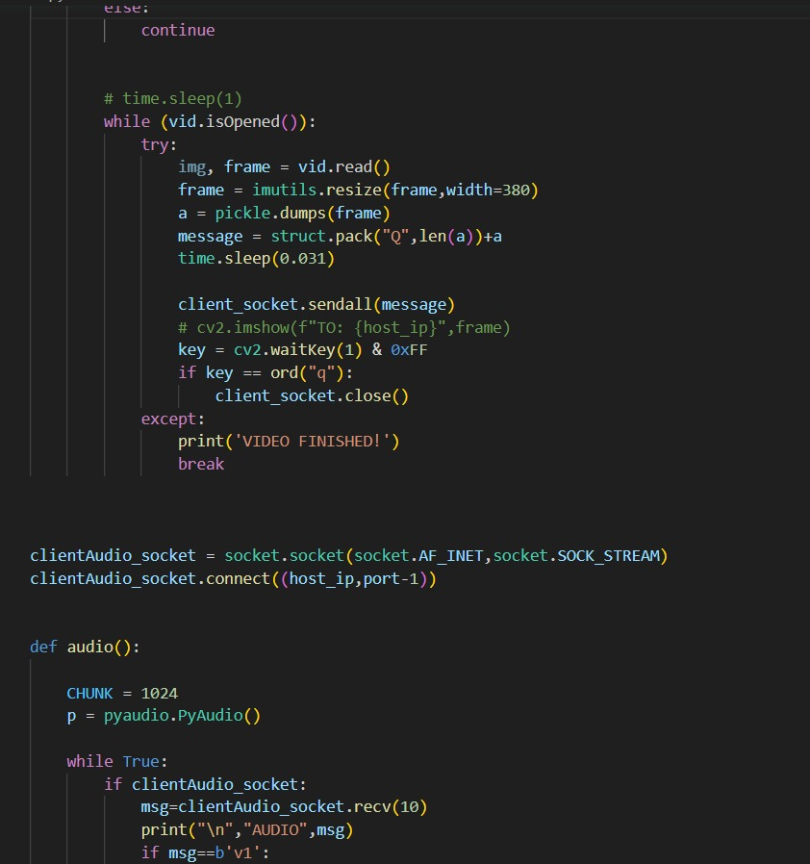

**Snips from server code (Eathernet):**

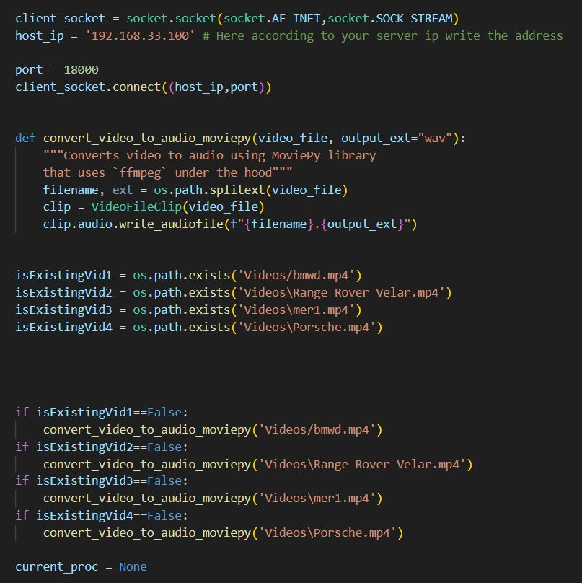

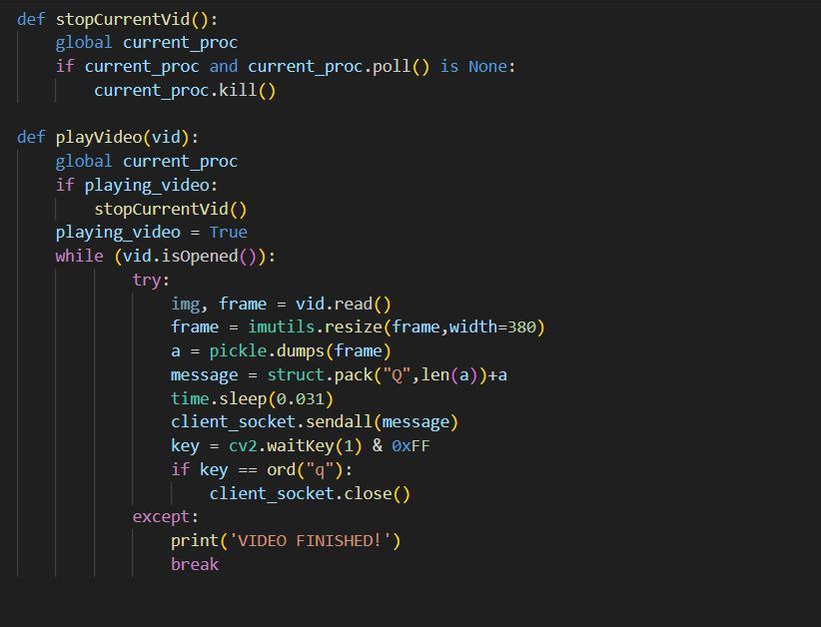

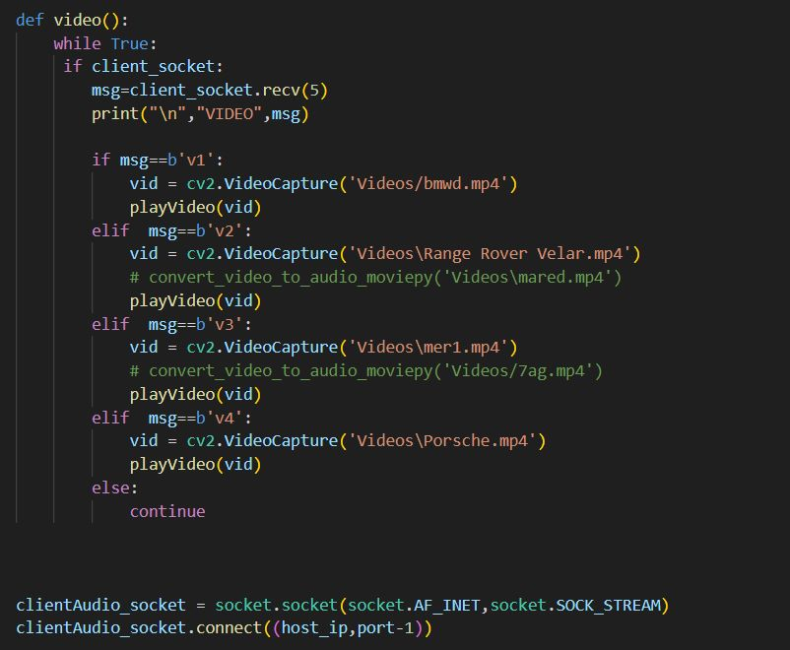

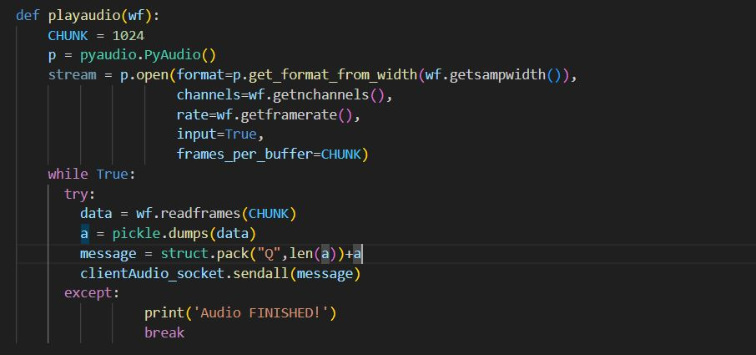

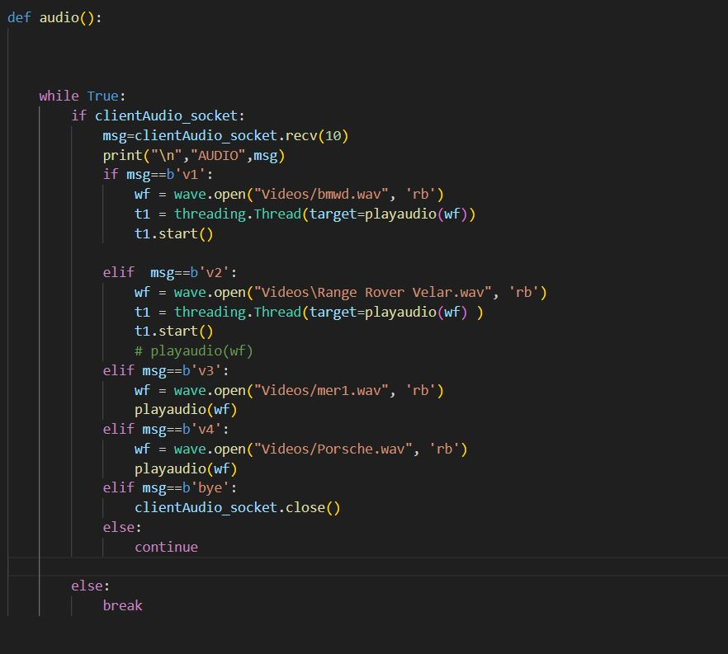

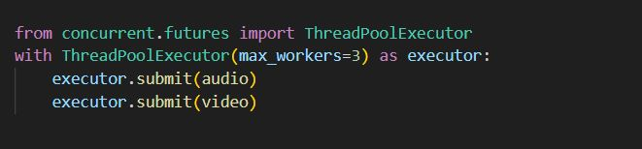

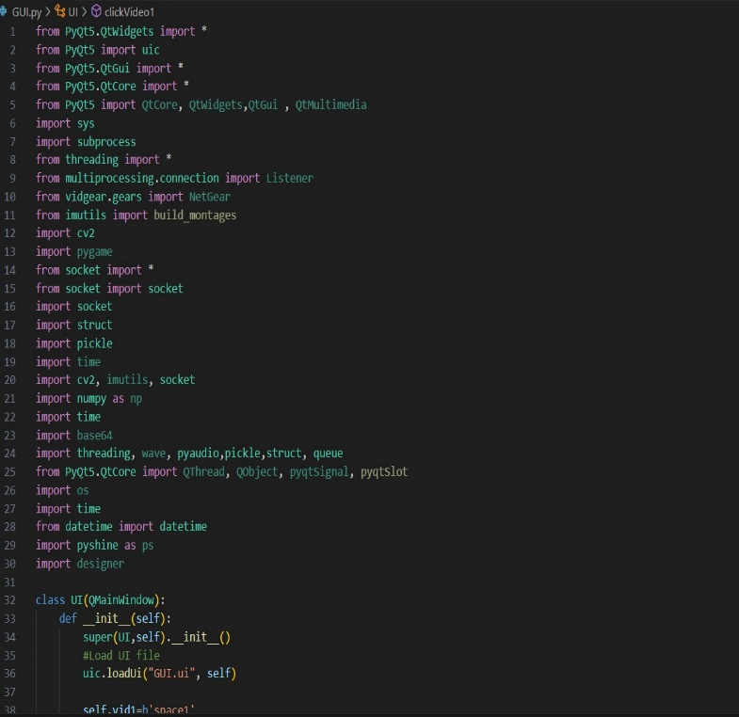**Client code:**

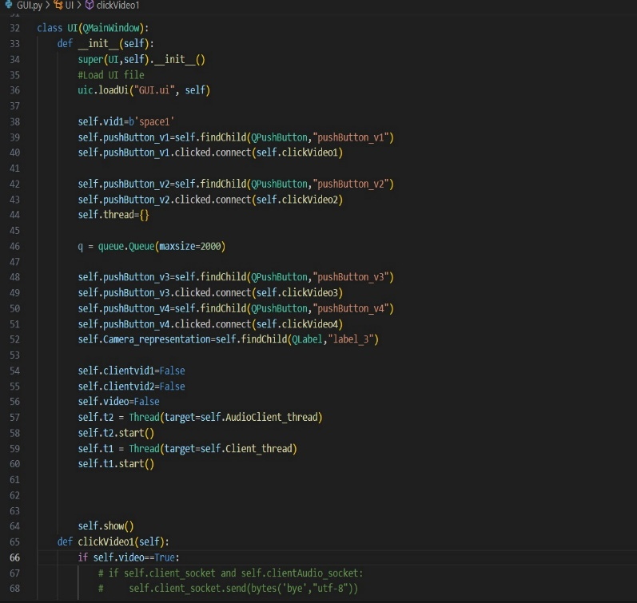

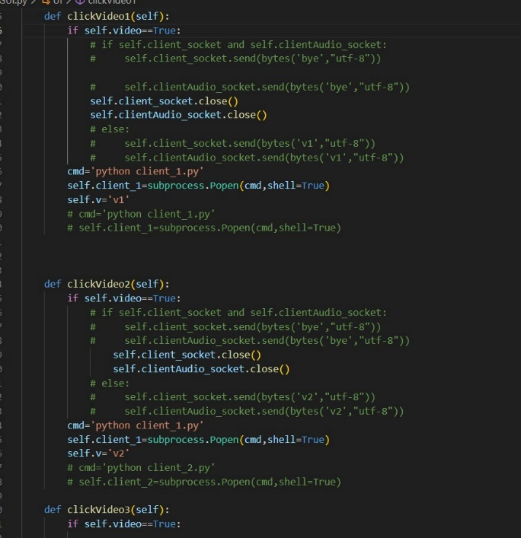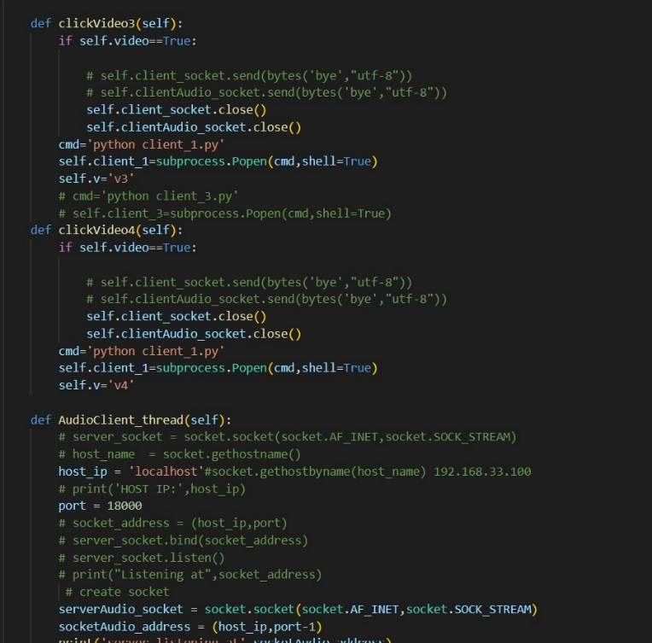

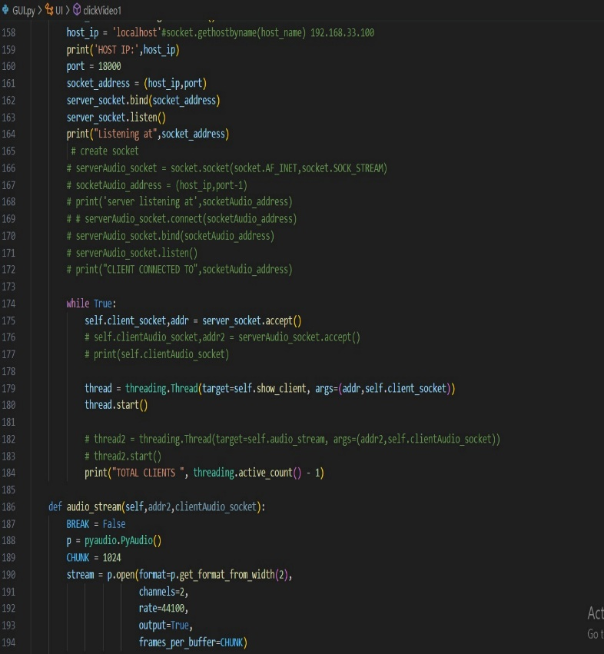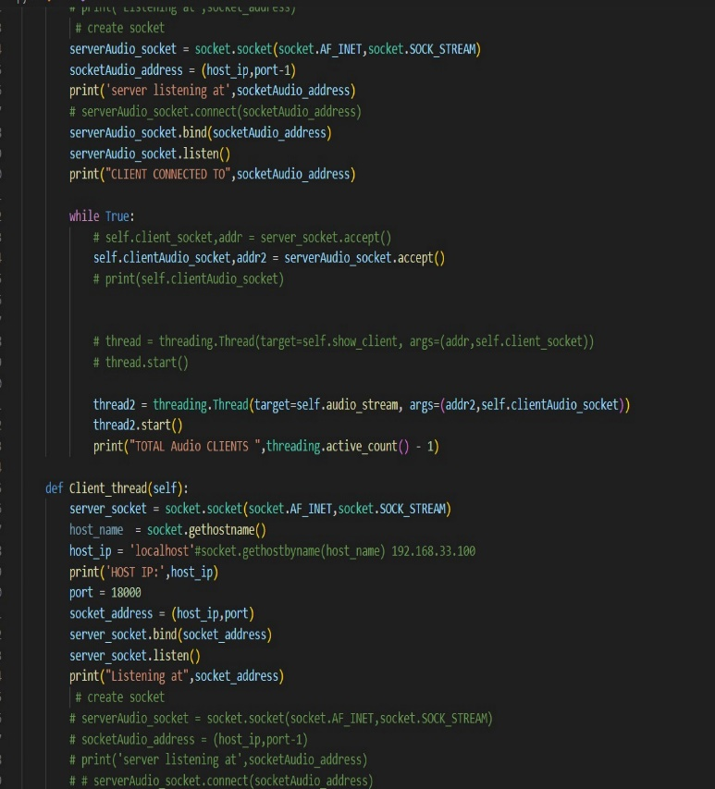

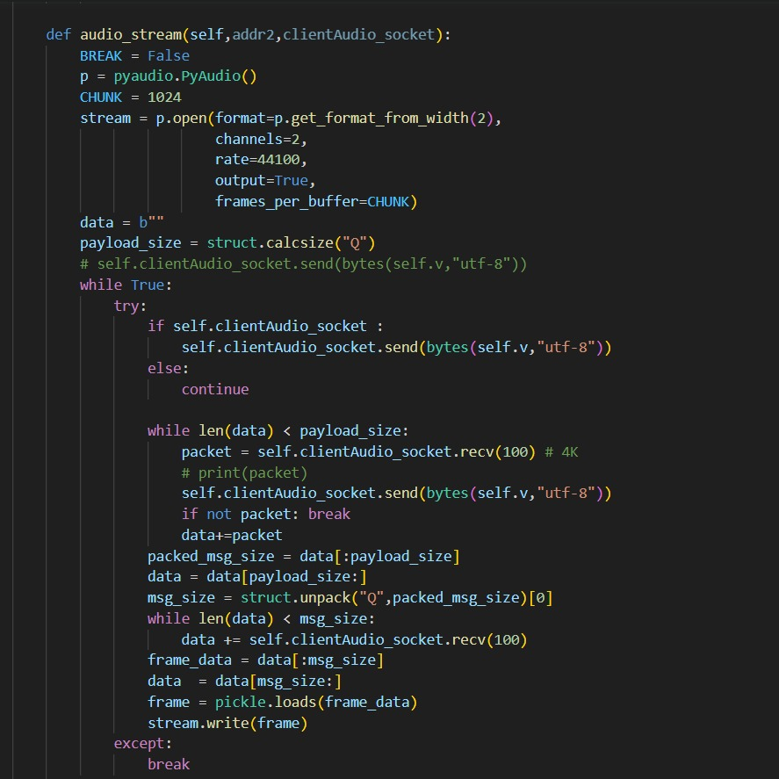

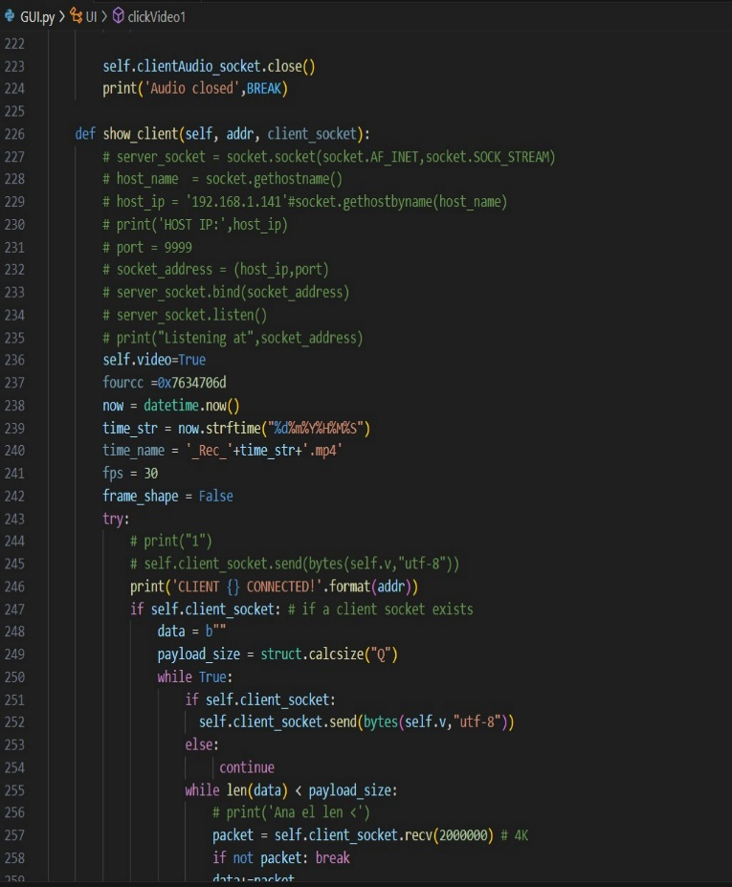

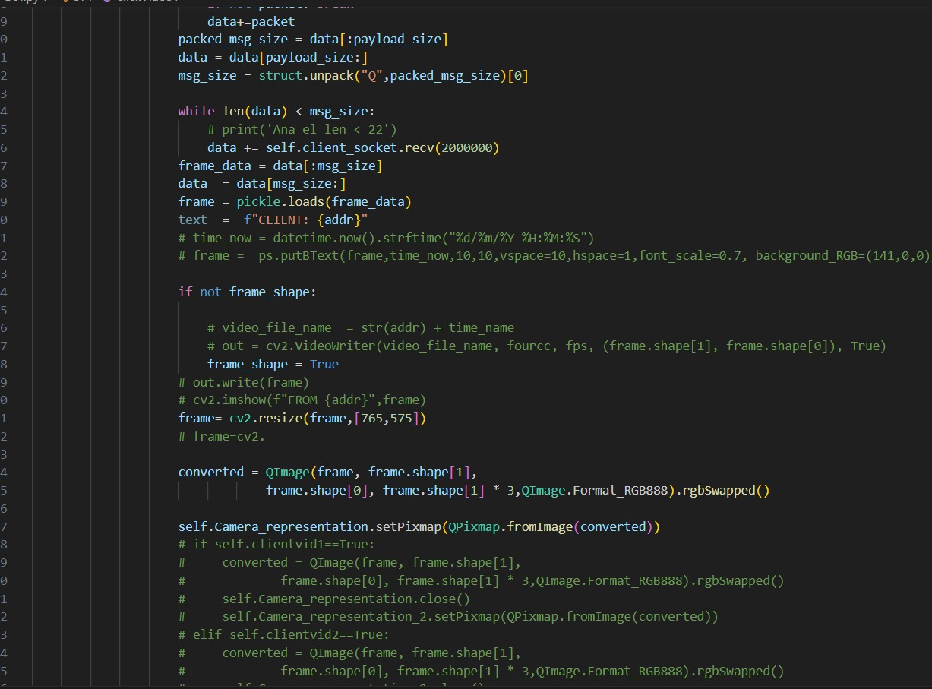

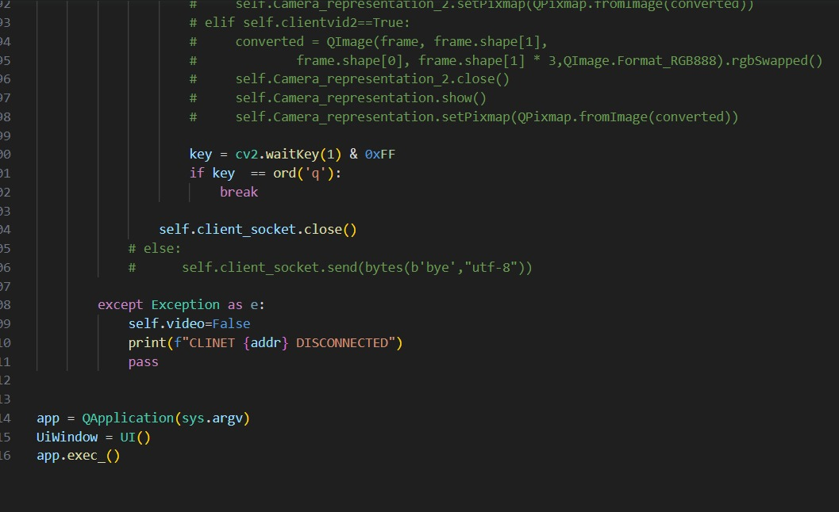

**Summary:**

In summary, a video streaming server is an application that allows users to access and stream video content from a central location. It can be set up using various programming languages and technologies and provides a personalized and user-friendly experience for its users.